WORKSHOP: Online Experiments

In this assignment you will analyze data generated by A/B (split) testing and learn how to use multi-armed bandit experiments using Thompson sampling. Follow the steps below to complete the assignment filling out the parts marked in green.
Part I. A/B testing - Comparing Two Ad Copies
- Download ab_test_data.txt file from the class site. The file contains user level conversion data (“1” for “ad was clicked”, “0” otherwise) collected from two versions of the Netflix ad for the featured movie “To All the Boys I've Loved Before.”

- Calculate responses rates $\hat{p}$generated by ad A and ad B.

 | Response rate
Ad A | 15.01%
Ad B | 18.14%

- Calculate 95% confidence intervals for response rate for each ad (Hint: $Z_{1-\frac{α}{2}}= 1.96$)
 | 95% confidence interval
 | Lower bound | Upper bound
Ad A | 0.1276 | 0.1726
Ad B | 0.1575 | 0.2053

- Briefly comment on your findings:
Ad B has a higher estimated response rate than Ad A. The two confidence intervals overlap, so the difference is not definitive based on the intervals alone. However, the observed results suggest that Ad B may perform better than Ad A.

- To prepare for hypotheses testing calculate the following test statistic:
$Z=\frac{sample statistics - hypothesized difference under H_{0}}{Standard Error under H_{0}}$
HINT: Under H_{o} the standard error can be calculated as:
${SE}_{{\hat{p}}_{A}-{\hat{p}}_{B}}=\sqrt{\hat{p}(1-\hat{p})\left(\frac{1}{n_{A}}+\frac{1}{n_{B}}\right)}$, where $\hat{p}=\frac{X_{A}+X_{B}}{n_{A}+n_{B}}$
Z (test statistic) | 1.861

- Test if there is a difference between the two ads using two-sided test and report p-value.
HINT: for Norm CDF use pnorm() function in R or NORM.DIST in EXCEL

p-value | 0.0627

Comment if you reject your Null hypothesis (assume 95% confidence level):
Do not reject H0 at the 5% level

- Now, imagine that instead of testing for difference between the two ads you want to establish if the ad B is better than the ad A in generating trailer views. Calculate and report the p-value.
p-value | 0.0313

Assuming that you want to be at least 95% certain that the ad B is better than ad A, would you move forward with ad B?
We would not move forward with Ad B given the 95% confidence interval. The p-value for the one-sided test for Ad B outperforming Ad A yields a p-value of 0.9972, indicating no evidence that Ad B is better.

- Finally, assume that your have ran your experiment for a bit longer and now collected twice as many observations for each version of the ad. The conversion rate remained the same. Repeat your calculations above and report the results for one- and two- sided tests.

Test | p-value | Reject Null (Yes/No)
two-sided | 0.00848 | Yes
one-sided | 0.00424 | Yes

HINT: you can check your calculations by using prop.test() function in R. Set “correct=” option to FALSE.

Part II. Multi-armed bandit experiments using Thompson sampling.
Now assume that instead of establishing the best performing ad (exploration) first and then using the winning ad in a subsequent advertising campaign (exploitation), you want to combine these two steps by allocating more impressions to the currently best performing ad, while collecting statistics on both ads to identify the best. This exploration versus exploitation tradeoff could be implemented in the form of a multi-armed bandit experiment. While various algorithms have been proposed for this task, our implementation will be based on the so-called Thompson sampling (e.g., see Scott 2014).

Method Intuition

At the core of multi-armed bandit experiments is Bayesian updating. Each ad is associated with a performance characteristic q_{a} (e.g., click-through probability) which is unknown to the analyst and modeled by a Beta distribution. As the ad is served to a prospective customer, the customer’s response to the ad (i.e. no click/click or 0/1) can be modeled as a Bernoulli random variable. The more responses the analyst observes for each ad, the more certain they can be about the unknown performance characteristic q_{a} by updating its distribution parameters. Importantly, when choosing which ad to show to the next consumer, the algorithm uses the current estimates of the performance characteristic to give a greater chance to be shown to the winning ad. Hence, the main two components of the algorithm are:

- Bayesian updating of the distribution of performance characteristic:
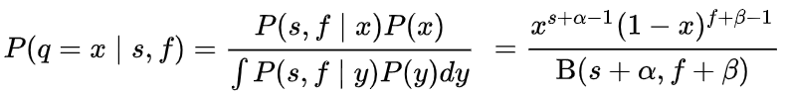
where s and f represent the number of successes and failures (correspondingly) up to the point t; α and β are parameters of the prior distribution of q (i.e. performance characteristic) and P is a posterior distribution of interest (Beta).

Example in R:

posterior_alpha = alpha_prior + num_successes
posterior_beta = beta_prior + num_failures
q_Draws = rbeta(length(alpha_prior), posterior_alpha, posterior_beta)

As the analyst observes the number of successes and failures in the next period, posterior parameters are getting updated as shown in the example.

- Allocation of ad impressions for next testing period (e.g., next day):

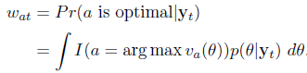
For example, if the analyst has an inventory of 1,000 impression (Imp) to serve on day t then the number of impressions allocated to each ad (variant) will be proportional to w_{at}.
In our case the general expression shown above simplifies to:
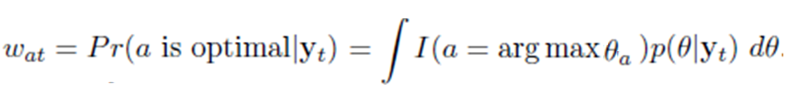
From the implementation standpoint this integration could be approximated by drawing a large number of samples N (e.g., 500-800) from the posterior distribution of q (as defined in part a), and then calculating the shares of wins for each ad.

Example in R:

WinningVariantsPerDraw = max.col(q_Draws)
TotalWinsbyVariant = table(WinningVariantsPerDraw)
W_at = TotalWinsbyVariant / N

Finally, the impression allocation across ads for the next period can be determined by drawing from a multinomial distribution as shown in the R code below:

AllocationPerAd = rmultinom(1, Imp, W_at)

Steps of the Analyses

To get a hands-on experience with multi-armed bandit experiments perform the following analyses and put your results with comments in the parts marked in green. Start with downloading the sample R code (“Workshop_ThompsonSampling.r”) from ELMS. Open the code in RStudio and run it. Carefully study the code making sure you understand each step. Refer to Scott (2014) paper as needed. The code implements Example 1 presented on page 2, and you should focus on Section 2, 3, 3.1 and 4.1 of the paper.

- Exploring Bayesian updating
  - For this question, you will be working with 4 ads (variants). Set the “True” success probabilities to (0.04, 0.01, 0.01, 0.03). (HINT: use vector q_actual_performance).
  - Modify the code to ignore Thompson sampling-based allocation, instead make allocation equal across all variants. (HINT: comment out the line of code where the stochastic allocation is done and hardcode fixed allocations)
  - Run the simulation for T = 1000 times (e.g., days) for a single replication (i.e. set REPLICATIONS = 1).

NOTE: If you are getting an error: “Error in plot.new() : figure margins too large” make the “Plots” window in RStudio larger and rerun your code.

  - Refer to “VISUALIZATION #1: PLOTS FOR A SINGLE RUN” visualization section in R code to generate plots. Copy the 4-plot graph here: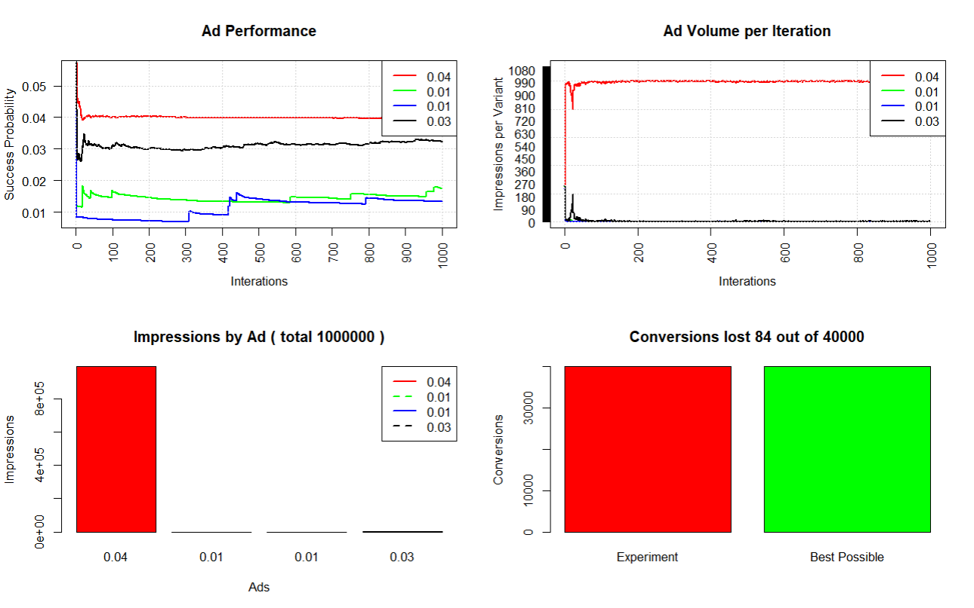
  - Explain what is depicted by each of the four plots in (d), assuming you present your result to a non-technical audience.
Ad performance shows the estimated success probability, or conversion rates, of each ad the more the ad is run. The better performing ads, those with the conversion rates of .04 and .03, level themselves out around their true conversion rates much sooner than the two ads with the rate of .01. These take much longer to stabilize.

Ad volume per iteration compares the impressions that each ad receives the more they are run. Early on, each of the ads seem to receive a similar share of the impressions, but this changes after about 25 iterations. Beyond this point, most impressions go to the better performing ad and drop off for the remainder of the ads. This shows that the algorithm quickly learns what performs the best and continues to iterate that one.

Impressions by ad shows that the better an ad performs, the more impressions it receives. The ad with 40% conversion rate received nearly all of the impressions compared to the other three ads that received little to no impressions.

The conversion lost chart shows how many total conversions were completed within this test and how many would be completed if we chose to use the best performing ad each time. The bars are very close to one another in area suggesting that the performance was almost ideal. The title suggests that only 84 of 40000 conversions were lost, which is a very good success rate. This is proof again that the system learns what ads perform best and prioritizes showing these.
  - Now assume that only 4 people are exposed to your ads per day. Modify the code to reflect this scenario and rerun the simulation. Copy the new 4-plot graph here:
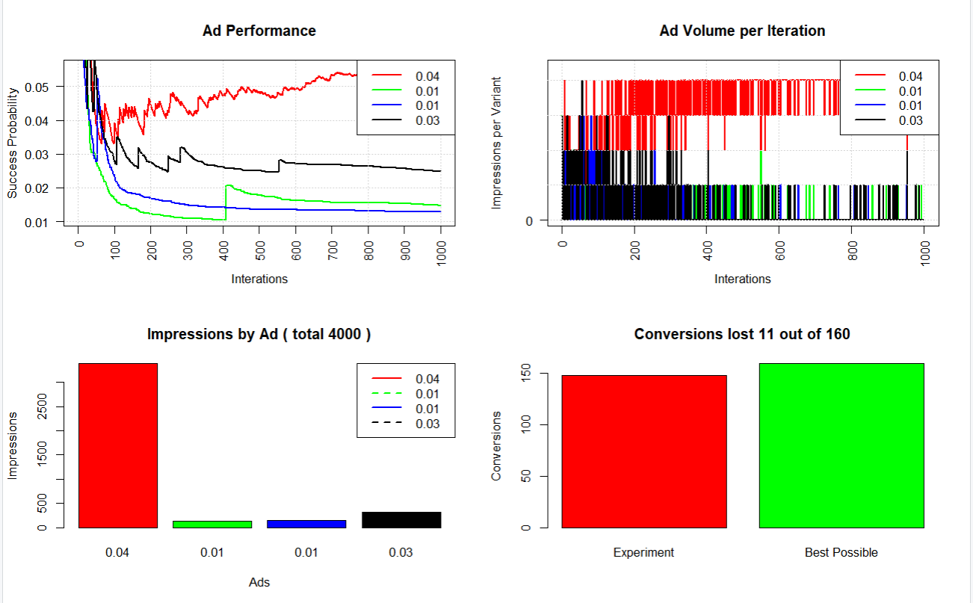
  - Explain the difference in “Ad Performance” plots between (d) and (f).
The ad performance chart for (f) has a much smaller audience, so the system gives less time to see how well each ad performs and instead funnels attention to the ad with the highest conversion (40%) to convert more of the audience. Almost instantly, the remainder of the ads drop off closer to the bottom line where as in (d), each ad had fluctuation in success probability through at least half of the campaign.
- Exploring Thompson Sampling
  - Reload the original R code from ELMS (or just reset the changes you made in part 1). Set the “True” success probabilities to (0.04, 0.01, 0.01, 0.03)
  - Run the simulation for T = 1000 times for 1 replication (i.e. set REPLICATIONS = 1).
  - Copy the 4-plot graph here:
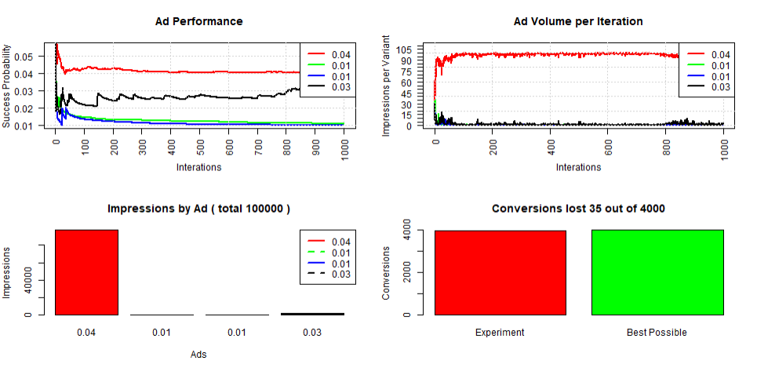
  - Explain the differences between the corresponding plots depicted in (1.d) and (2.c), assuming you present your results to a non-technical audience.
In the first set of plots (1.d), impressions are distributed evenly across all ads, so learning happens more slowly and each ad improves at a similar pace. As a result, weaker ads continue to receive traffic throughout the experiment, which leads to inefficiencies and more lost conversions. In contrast, in the second set of plots (2.c), the algorithm quickly identifies the better-performing ad and shifts most of the impressions toward it. This causes the best ad’s performance to stabilize faster, while poorer-performing ads receive very few impressions and are effectively phased out. Overall, the second approach is more efficient because it focuses traffic on what works, leading to faster learning and fewer lost conversions.

  - Set the “True” success probabilities to (0.04, 0.04, 0.01, 0.04)
  - Rerun simulation multiple times making a note on how plots vary across the runs.
  - Explain the observed patterns focusing on “Ad Volume per Iteration” and “Impression by Ad” plots.
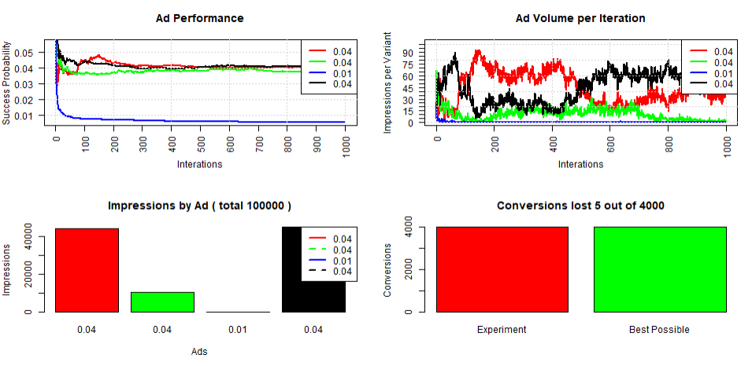
The “Ad Volume per Iteration” plot shows that impressions are not distributed evenly over time. Early in the experiment, impressions fluctuate across all ads as the algorithm explores their performance. As more data is collected, the algorithm begins to shift impressions toward the better-performing ads (those with 0.04 CTR). However, because three ads have identical performance (0.04), the algorithm cannot clearly distinguish a single winner. As a result, impressions move back and forth between these top-performing ads, creating visible fluctuations over time.
The worst-performing ad (0.01, blue) quickly receives almost zero impressions and remains low throughout the experiment, showing that the algorithm efficiently eliminates poor options.
Impressions by Ad (Bar Chart)
The “Impressions by Ad” plot shows that total impressions are concentrated among the top-performing ads, but not evenly distributed between them. One or two ads receive more impressions than others, even though they have the same true performance.
This happens because early random outcomes influence the algorithm’s belief about which ad is best, causing it to favor certain ads more than others. As a result, the exact distribution of impressions varies across runs. The lowest-performing ad (0.01) receives almost no impressions overall, confirming that the algorithm successfully minimizes exposure to ineffective ads.

- Comparing a multi-armed bandit with a static approach
  - For this question, you will be working with 2 ads (variants). Set the “True” success probabilities to be equal to the empirical response rates $\hat{p}$generated by ad A and ad B in Part I - A/B testing of this workshop.
  - Using the G*Power software determine required sample size to perform a one-tailed Z-test for the difference in two independent proportions (set type of power analysis = a priory, α = 0.05 and Power = 0.80, Allocation ratio N2/N1 = 1).
Total sample size needed = 3490
Provide a screen shot from G*Power showing your estimations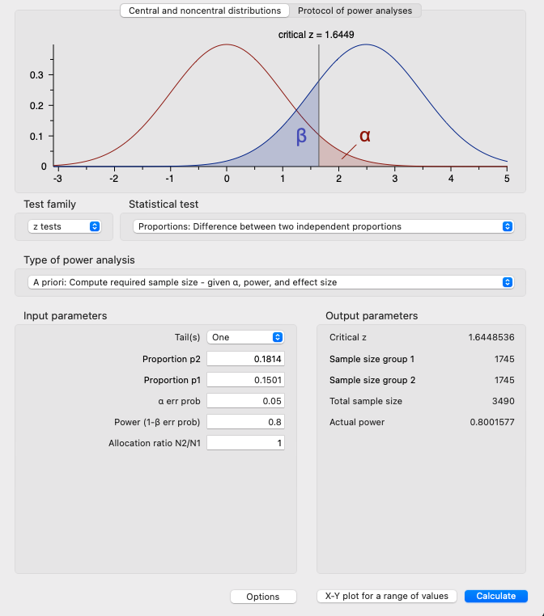

  - Assume that you can reach only one person with your ads per day (i.e., only one ad per day can be served, use ImpressionsPerPeriod variable for that) and want to get the number of impressions calculated in step (b) above. Modify the code to reflect this scenario and rerun the simulation. Copy the new 4-plot graph here:
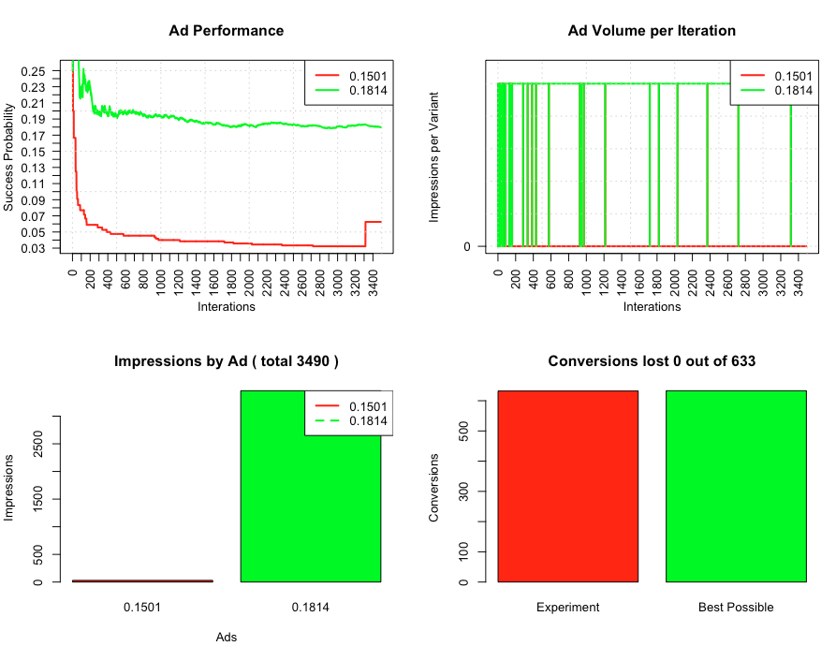

  - Since the multi-armed bandit is a stochastic process, simulation results are likely to vary across runs. Hence, we want to look at the distribution of the outcome of interest and compare it with a static A/B testing approach. Next, modify the code to set the number of replications to 100 (REPLICATIONS = 100).

  - Run the simulations, and then refer to “VISUALIZATION #2: CONVERSIONS LOST ACROSS REPLICATIONS” visualization section in R code to generate plots. Copy the 2-plot graph here:
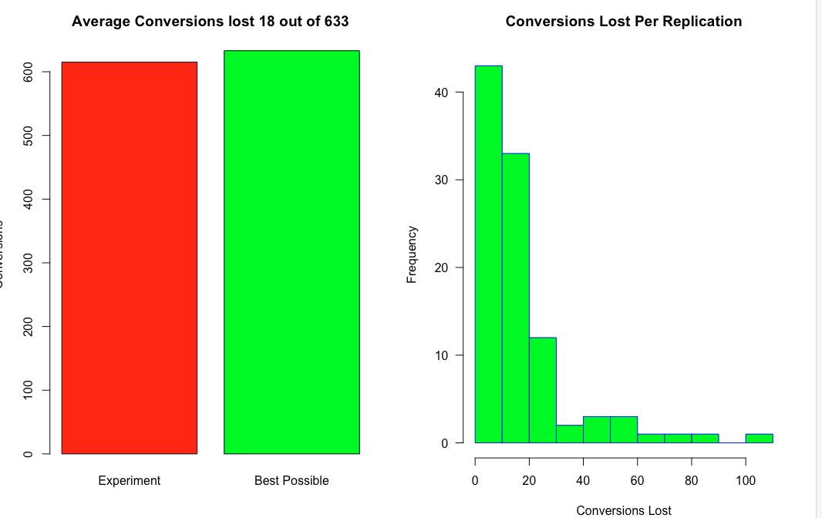

  - Calculate the number of Conversions Lost for the static case (see Section 4.1 of Scott 2014). How does it compare to the Conversions Lost in the multi-armed bandit experiment?
Conversions Lost in Static Case = 54.6185

  - Modify the code to allow for early stopping based on “regret” threshold at 0.01. Run the simulations, and then refer to “VISUALIZATION #3: STOPPING BASED ON REGRET” visualization section in R code to generate plots. Copy the 2-plot graph here:

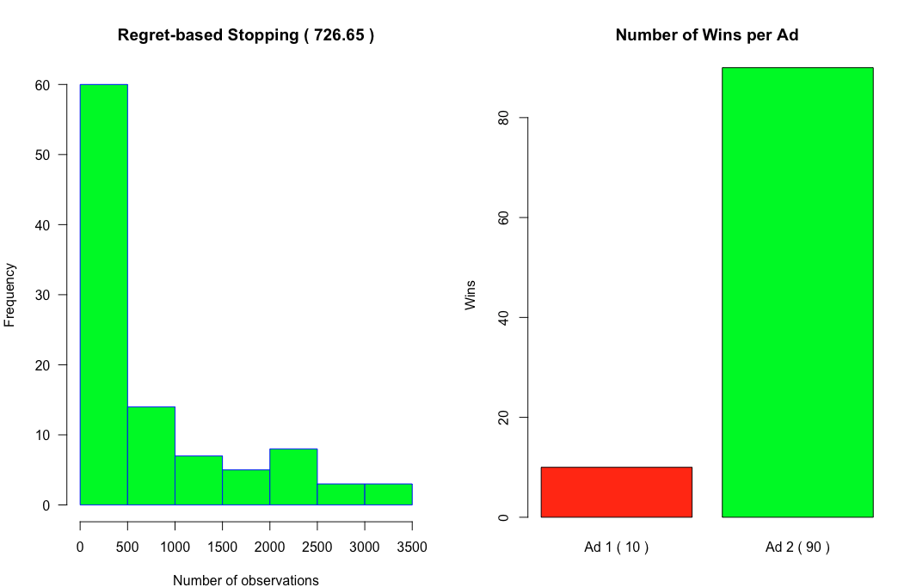
  - Comment on your results. Does the algorithm always find the best performing Ad? Explain.
The algorithm does not always find the best ad. Since Thompson sampling is stochastic, results vary across runs. Early stopping makes the process more efficient, but it may stop before the evidence is fully stable.

PUT YOUR ANSWERS IN THE CORRESPONDING HIGHLIGHTED AREAS IN THIS DOCUMENT
Submit your report through ELMS

